**Competitive Shooters of Lake Norman USPSA August 21, 2025**

**COURSE DESIGNER:** Ike Starnes

|  |
| --- |
| **START POSITION: See written stage briefings.** |

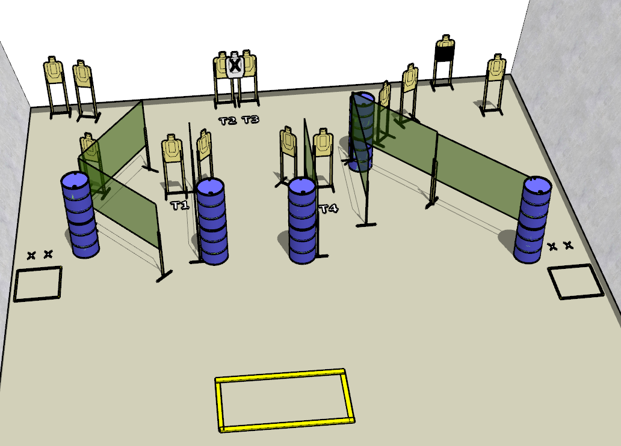

**Written Stage Briefing:**

**Stage 1 – Revenge Is Never A Straight Line. -** is a 26-round, 120 point, Comstock Course. There are 12 cardboard targets and some noshoots. The best 2 hits per cardboard target will be scored.   
**Handgun start position** Both feet on the Xs. The handgun is **loaded** and holstered.

**PCC start position** Both feet on the Xs. PCC is **loaded** with stock touching belt.

On the audible start signal, engage targets from within the shooting area.